1. About Hoa Sen Group

Hoa Sen Group is a prominent Vietnamese firm that focuses on producing and selling steel items. Since its establishment in 2001, the company has expanded considerably and is now one of the most significant steel manufacturers in Vietnam, operating in both local and global markets. Hoa Sen Group has gained recognition for its exceptional standards, inventive approaches, and effective practices, and has diversified its operations to include other sectors such as real estate, renewable energy, and logistics. The purpose of this study is to assess and predict Hoa Sen Group's quarterly gross sales revenue, which will offer valuable insights into the company's performance and assist in forecasting its stock price.

2. Gross sales Revenue

This study collected data about gross sales revenue in 59 quarters (from 2008 to the third quarter of 2022) from the group’s financial report

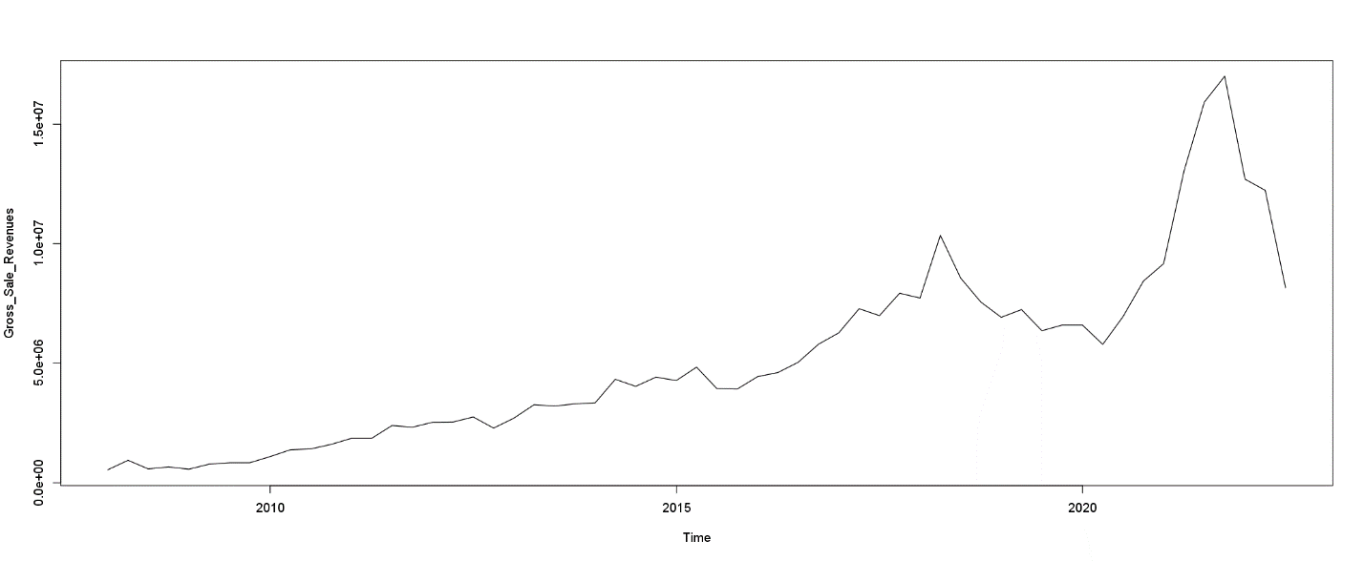

This time series line shows the gross sales revenue of Hoa Sen Group over a period of 14 years, from 2008 to the third quarter of 2022. The data indicates that the company has experienced fluctuations in revenue, with some years showing significant growth while others experiencing declines. Overall, the trend appears to be positive, with revenue increasing steadily until 2017, and then experiencing a slight dip in the following years before rebounding to a new high in 2021. The decline in overall sales was attributed to lower demand both domestically and internationally, as well as rising costs of materials, exchange rates, and interest rates. Despite the negative impact of the Covid-19 pandemic, HSG experienced its most successful year in terms of gross revenue in 2021, reaching VND 17,005 trillion, the highest amount in the history of the company.

Forecast by trend model:

|  |  |  |  |  |
| --- | --- | --- | --- | --- |
| Model | RMSE | MAPE | RMSE (4 last obs) | MAPE (4 last obs) |
| Model 1: Linear time trend (series ~ time) | 1678583 | 26.67% | 3856930 | 25.72% |
| Model 2: log-linear time trend (log(series) ~ time) | 1787341 | 24.65% | 4383221 | 36.14% |
| Model 3: linear trend + seasonality (additive form) (series ~ time + seas) | 1668207 | 30.81% | 3794262 | 24.92% |
| Model 4: log-linear trend + seasonality (additive form) (log(series) ~ time + seas) | 1773465 | 24.4% | 4313139 | 35.41% |
| Model 5: linear trend + seasonality (multiplicative form) (series ~ time * seas) | 1647871 | 29.95% | 3515962 | 23.66% |

Overall, all five models have relatively high R-squared values, indicating a good fit to the data. However, the RMSE and MAPE values differ between the models. Model 2: (log-linear time trend) has a low MAPE value in case of all dataset, indicating the smallest average percentage error between actual and predicted values. However, it has the highest RMSE value among all the models. Model 4: (log-linear trend + seasonality) has the lowest MAPE value and a lower RMSE value compared to Model 2, indicating that it is a good choice for forecasting gross sales revenue.

In other hand, when we compare MAPE of these models in 4 last observations, there is huge different. Model 5 (linear trend + seasonality in multiplicative form) has the lowest RMSE (3515962) and MAPE (23.66%) values, indicating that it is the most accurate model among all other models in predicting the series values for the last four observations. Following up, Model 3 (linear trend + seasonality in additive form) also performs well, with an RMSE of 3794262 and an MAPE of 24.92%, which is very close to the performance of Model 5. To conclude, model 4 appears to have the best overall fit for the dataset, but when considering only the last 4 observations, model 5 exhibits the highest level of accuracy.

Holt-Winter model:

|  |  |  |  |  |
| --- | --- | --- | --- | --- |
| Model | RMSE | MAPE | RMSE (4 last obs) | MAPE (4 last obs) |
| Model 6: Holt-Winter Additive form | 1138826 | 15.73% | 2935848 | 23.78% |
| Model 7: Holt-Winter Multiplicative form | 1027275 | 15.77% | 2593691 | 17.77% |

Consider at the MAPE values, we see that both models have similar performance, with the Holt-Winter Additive form having a slightly lower MAPE (15.73%) compared to the Holt-Winter Multiplicative form (15.77%). This indicates that both models are equally good at predicting the percentage error in the time series. Furthermore, we can also look at the performance of the models on the last 4 observations of the time series. In this case, the Holt-Winter Multiplicative form performs better, with a lower MAPE (17.77%) compared to the Holt-Winter Additive form, which has MAPE of 23.78%. This suggests that the Holt-Winter Multiplicative form is better suited for predicting the recent values of the time series

Decomposition of Gross Sale Revenue series (additive):

In general, we can see that the gross sale revenue has increased over time, with some fluctuations along the way. From 2008 to 2010, the values increased steadily, followed by a sharp increase from 2011 to 2017. After a dip in 2018 and 2019, the values increased again in 2020 and 2021.

|  |  |
| --- | --- |
|  | The seasonal series highlights that the gross sales revenue is heavily influenced by Q1 and Q2, with Q1 showing a significant decrease of around 281879 and Q2 indicating a sharp increase of approximately 208681. This suggests that there is a substantial drop in demand during Q1, followed by a substantial surge in demand in Q2.  We remove the seasonal impact from the time series and retain only the trend and random factors. This will yield a Seasonal Adjustment series, which we can use to construct a regression model. Since the model model is a seasonally adjusted model, |

it is necessary to incorporate the decomposed seasonal factor when making predictions or computing metrics such as RMSE and MAPE.

|  |  |  |  |  |
| --- | --- | --- | --- | --- |
| Model | RMSE | MAPE | RMSE (4 last obs) | MAPE (4 last obs) |
| Model 8: Additive seasonal adjustment ~ time | 1671357 | 30.74% | 3857107 | 25.79% |

After conducting tests on 8 different models, it is evident that the Holt-Winter model performs better than trend models. Hence, we could consider utilizing the Holt-Winter model either in its Additive form or Multiplicative form to predict the gross sales revenue of HSG.

3. Stock Price of HSG:

|  |  |
| --- | --- |
| The quarterly analysis of gross sales revenue revealed that Hoa Sen Group had achieved an all-time high profit of 17,005 billion in Q4 of 2021. Nonetheless, 2022 saw a reduction in gross sales revenue, starting at 12697837 billion in Q1 and declining to 8152489 billion in Q3, which is almost half of what was recorded in the same period last year, which was 15,922 billion in Q3 of 2021. As a result, the stock price of HSG reflected opposite trends between the two years. In 2021, the stock |  |

price showed a positive trend, while in 2022, it exhibited a downward trend.

The series was tested for a unit root by Dickey-Fuller Unit root test, and it was discovered that it was stationary with a drift after taking the first-order difference. Therefore, the value of "d" in the ARIMA(p, d, q) model is 1. Additionally, to determine the two remaining orders of the ARIMA model, PACF and ACF plots can be used.

|  |  |
| --- | --- |
|  |  |

Upon examining the PACF and ACF plots, it becomes evident that there is no dependence on error terms, and there is no dependence on past values. To draw a comparison, a few additional ARIMA models were fitted to the HPG stock price series:

|  |  |  |  |  |  |  |  |  |
| --- | --- | --- | --- | --- | --- | --- | --- | --- |
| Model | AIC | BIC | RMSE | MAPE | RMSE (10 last obs) | MAPE (10 last obs) | RMSE (first 10 obs 2023) | RMSE (first 10 obs 2023) |
| ARIMA (1,1,1) | 1345.41 | 1362.25 | 0.925 | 2.7% | 0.489 | 3.3% | 1.379 | 9.86% |
| ARIMA (2,1,1) | 1347.4 | 1368.45 | 0.925 | 2.7% | 0.489 | 3.3% | 1.379 | 9.86% |
| ARIMA (0,1,1) | 1343.44 | 1356.07 | 0.925 | 2.7% | 0.489 | 3.3% | 1.381 | 9.88% |
| ARIMA (2,2,1) | 1347.9 | 1364.74 | 0.926 | 2.7% | 0.48 | 3.3% | 1.67 | 11.95% |
| ARIMA (5,2,3) | 1351.41 | 1389.28 | 0.919 | 2.7% | 0.46 | 2.9% | 1.589 | 11.33% |

The ARIMA(5,2,3) model was most suitable for modeling the data of the final 10 days of 2022, but it performed poorly in predicting the first 10 days of 2023. On the contrary, the ARIMA(0,1,1) model had the lowest AIC and BIC values. However, surprisingly, the ARIMA(1,1,1) model had the best performance overall and also yielded the smallest forecast error for the entire time series as well as the first 10 days of 2023.

|  |  |
| --- | --- |
|  |  |

. To evaluate the ARIMA(1,1,1) model, inverse roots are inside the unit circle and a p-value of 0.00 says that the model’s residuals exhibit serial correlation. Upon examining the residuals of the other models, we have found evidence of serial correlation in those models as well. As the result, forecast value of these models might not be reliable for predict HSG stock price

Forecast result of ARIMA(1,1,1) model on stock price of HSG is presented below:

